Moodle2Word Questions – English template

BIOM1S1-MA1
Secondary occlusal trauma |  |  | MA
Default mark: |  |  | 1
Shuffle the choices? |  |  | Yes
# | Answers | Feedback | Grade
 | Is due to a lack of posterior alignment. |  | -50
 | Is due to poorly conducted orthodontic treatment. |  | -50
 | Causes bone loss on a periodontally healthy tooth. |  | 50
 | Does not widen the periodontal space. |  | 50
 | Causes dental migration |  | -50

BIOM1S1-ES1
What do you think about Cryptocurrency? Paraphrase text |  |  | ES
Default mark: |  |  | 5
Response format: |  |  | Pain text
Require text: |  |  | Yes
Input box size: |  |  | 15
Allow attachments: |  |  | 0
Require attachments: |  |  | 0
 | Response template | Information for graders

BIOM1S1-TF1
The capital of Lebanon is Beirut |  |  | TF
Default mark: |  |  | 1
 | Answers | Feedback | Grade
 | True |  | 100
 | False |  | 0
 | General feedback:

BIOM1S1-MC1
Regarding the distribution of medications in the body: |  |  | MC
Default mark: |  |  | 2
Shuffle the choices? |  |  | Yes
# | Answers | Feedback | Grade
 | Plasma proteins constitute the only form of transport for substances (endogenous or medicinal) in the blood.  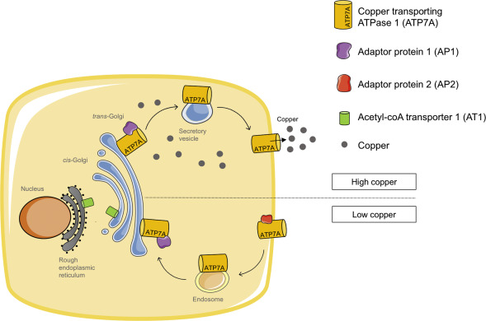 |  | 0
 | Transcortin is capable of transporting copper. |  | 100
 | Weak acids have numerous binding sites on albumin and bind with high affinity. |  | 0
 | Only the bound fraction of the drug is capable of diffusing into the body. |  | 0
 | If the volume of distribution of a molecule is high, then this molecule will have a low plasma concentration. |  | 0

